# Waste Sorter

## A Project Work Synopsis

*Submitted in the partial fulfillment for the award of the degree of*

## BACHELOR OF ENGINEERING

**IN**

### ARTIFICIAL INTELLIGENCE and MACHINE LEARNING

**Submitted by:**

**Aakash Kumar**

### 18BCS6007

**Anirudh Tyagi**

### 18BCS6040

**Mrigakshi**

### 18BCS6006

**Shubham Mishra**

### 18BCS6073

**Pratibha**

### 18BCS6093

**Under the Supervision of:**

### Somsirsa Chatterjee



**CHANDIGARH UNIVERSITY, GHARUAN, MOHALI - 140413,**

**PUNJAB**

#### September 2020

**Table of Contents**

Title Page i

Abstract ii

List of Figures iii

List of Tables (optional) iv

Timeline / Gantt Chart v

v

1. **INTRODUCTION* 1** 
   1. Problem Definition 1
   2. Project Overview/Specifications* (page-1 and 3) 2
   3. Hardware Specification 3
   4. Software Specification 4

1.3.1 4

1.3.2

…

1. **LITERATURE SURVEY 5** 
   1. Existing System 5
   2. Proposed System 6

7

1. **PROBLEM FORMULATION**
2. **RESEARCH OBJECTIVES 40**
3. **METHODOLOGY 47**
4. **TENTATIVE CHAPTER PLAN FOR THE PROPOSED WORK**
5. **REFERENCES**
6. **APPENDICE**

**Waste Sorter**

#### 1 INTRODUCTION

##### 1.1 Problem Definition

##### Pollution is one of the serious threats in our society. There are three major types of pollution, air pollution, water pollution and land pollution. The rising level of pollution around the globe is becoming one of a major concern of common people, political parties and environmentalists. A lot of efforts have been made to reduce the air and water pollution levels and various initiatives like Clean India are put forward to reduce land pollution in India. Presently around 5.25 trillion litter objects are present in the oceans, this quantity is steadily increasing with every pass of day.

##### Detection of waste in the water is not a new issue and researchers of different domains like civil engineers, biomedical, etc. have contributed to different aspects of this issue. Presently when most our daily world problems are tried to be solved with help of AI why not try to find a solution to this problem as well.

##### 1.2 Project Overview/Specifications

##### In this project we have applied a deep learning based object detection model. This proposed model detects and classifies the different pollutants and harmful waste in water bodies as well as on land. It helps in detecting the waste in water and on land with the objective to help in cleaning the environment.

##### In this project, we will train a Convolutional neural network to classify images into different types of waste materials which help us further in achieving the above goal.

1.3 Hardware Specifications

1. Smartphone /Laptop (After deployment)

2. NVIDIA GPU 1050,1650,1050Ti.

1.4 Software Specifications

1. Python for programming

2. Jupyter Notebook

3. Anaconda

4. Google Colab

5. Android Studio (**\*\*optional**)

#### 2 LITERATURE REVIEW

2.1 Existing System

Image classifiers and detection systems with the help of AI is already an emerging technology today. While many of its use cases are already being put to use such as Automatic Fire Detection Systems, Detecting Number Plate of cars through surveillance cameras, etc. Detecting waste in water bodies and land can also be put into use. Research for building a waste detector in water bodies is already going on but no deployment is done yet.

2.2 Proposed System

We are working on a model that will help us detect waste in water bodies and land thus help us in combating the problem of pollution in our country. This model will detect and classify the waste material in water bodies and land using convolutional neural networks and we will try to deploy it using android studio.

**But the scope of this project is just to make the model and deployment will be done later on which will not be a part of the project, yet we will try our best.**

2.3 Market Need

As we know that the levels of pollution are rising in our country day by day, we need an urgent solution to combat this problem. Our product aims to ease the detection of waste in water bodies and land where it is difficult for the common man to reach.

2.4 Social Relevance

Our model can be promoted on social media as well through various channels and broadcasting. The promotion through social media will bring out a wave of environmentalists to use our product for making our environment clean. Further we want to bring it to the notice of the government to use our product on a large scale for cleaning the water bodies and landmarks on a large scale.

2.5 Data Collection

The datasets used in these projects are obtained from open source data collections. The links to the datasets used in this project are as follows:

1. [https://github.com/garythung/trashnet/blob/master/data/dataset-resized.zip](https://meet.google.com/linkredirect?authuser=0&dest=https%3A%2F%2Fgithub.com%2Fgarythung%2Ftrashnet%2Fblob%2Fmaster%2Fdata%2Fdataset-resized.zip)
2. <http://tacodataset.org/>
3. <https://github.com/Harsh9524/AquaTrash>

#### PROBLEM FORMULATION

The project- Waste Sorter is an initiative to solve some of the existing problems related to waste and pollution caused by it. It would also help some of the ongoing movements like clean India.

The problems it would solve are:

1. Most of the plastic waste is disposed of near or in water bodies due to which aquatic life is facing serious threats. This project will help in solving this problem by detecting the water in water and further classifying it so that it can be removed easily.
2. Poor waste management is the most dangerous problem specially in India. It causes a lot of other problems and diseases. Using this project, we can manage the waste more accurately.
3. Plastic pollution is the major problem these days. Plastic has also been banned in several areas but still managing the plastic waste is still a challenging task. This project will not only help us to manage plastic waste under water but in other areas too. It will classify different types of waste.

From the literature review, it is observed that studies highlight the need for an efficient and scalable approach for detecting waste. The existing techniques are not that efficient and accurate. So there is a need to develop more accurate waste detecting systems that can sort all types of waste in the image. There is also a need to deploy the waste sorter which has not been done yet but in this project will also try to build an android app related to.

#### RESEARCH OBJECTIVES

The proposed research is aimed to carry out work leading to the development of an approach for automatic waste detection in water bodies. The proposed aim will be achieved by dividing the work into following objectives:

1. Image classification. It will be done to classify different types of waste and other things in an image so that one can easily sort the waste.
2. Object Detection. The project will use object detection using neural networks to detect various types of waste in the pictures.
3. Since neural networks play an important role in image classification and detection. Therefore, it is also one of the main objectives.
4. At last, we will also try to build an android app which would be an optional objective.

#### METHODOLOGY

The following methodology will be followed to achieve the objectives defined for proposed research work:

1. Detailed study of previous similar projects and research papers was done as mentioned in the synopsis.
2. We used the ResNet34 pre trained neural network and on model Image Network.
3. The model consists of 34 layers.
4. The dataset that we are using in our model is TrashNet. TACO and AquaTrash will also be included.
5. We have used transfer learning i.e. the weights were freezed and only output and input images were changed.
6. CPU & GPU time computation was compared. GPU is found out to be faster on image processing.
7. Our output comes in five different classes.
8. The model can be deployed either on web or on Android apps using tensorflow lite(optional).

#### RESULTS AND DISCUSSION

The project classifies the above dataset of images containing waste images into six categories irrespective of land or water (paper,plastic,trash,cardboard,metal and glass). We were able to achieve 91.8% accuracy using the ResNet 34 model using transfer learning.

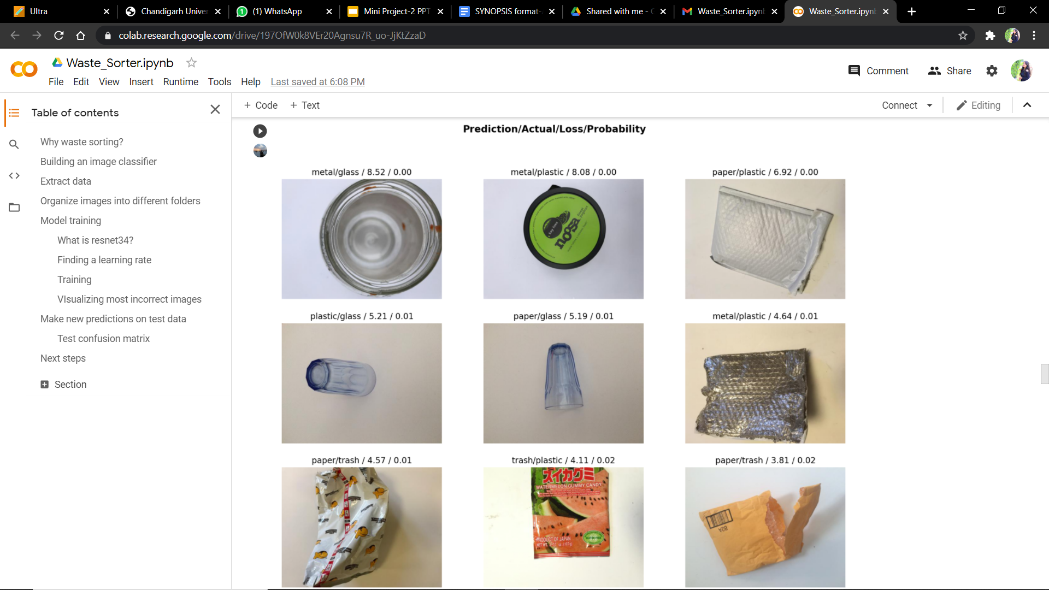

#### CONCLUSION AND FUTURE SCOPE

When it comes to waste management in India, nothing is quite right. The Central Pollution Control Board in its report which was released in 2009 indicates that around 62 million tons of solid waste is produced in our country every year, of which less than 20% or only 12 million tons are treated. This essentially means that the remaining 52 million tons of waste remain ‘untreated’ and contaminate land or make its way into rivers, lakes and wetlands. India is gradually becoming a water scarce country as water resources like ponds, lakes and rivers are on a decline. Despite environmental regulations that protect the quality of streams, lakes, and wetlands, solid waste in the form of trash, litter, and garbage often ends up in these surface waters.

This project intends to provide help in keeping our Land as well as our Water bodies clean from pollution. By the use of various machine learning models, this project is trained on a dataset of images to detect waste present on land and water bodies. It helps in sorting out the types of wastes into biodegradable and non biodegradable.

This project has ample space for research and combining various technologies together. In the future, this project can be combined with Android and Web technologies to develop a real life working model that can be used by various organisations that help keep our environment clean from pollution. Further, instead of working on images dataset to detect waste in images collected of land and water, it can be trained to detect waste from videos dataset as well. This upgrade will help in detecting waste by the use of video capturing on land and GoPro cameras in water bodies.

**TENTATIVE CHAPTER PLAN FOR THE PROPOSED WORK**

**CHAPTER 1: INTRODUCTION**

This chapter will cover the overview of Image Classifier, Object Detection and Neural Networks.

**CHAPTER 2: LITERATURE REVIEW**

This chapter includes the literature available for Automatic waste detection in water bodies and Image classifier for Waste sorting. The findings of the researchers will be highlighted which will become the basis of current implementation.

**CHAPTER 3: BACKGROUND OF PROPOSED METHOD**

This chapter will provide introduction to the concepts which are necessary to understand the proposed system.

**CHAPTER 4: METHODOLOGY**

This chapter will cover the technical details of the proposed approach.

**CHAPTER 5: RESULTS AND DISCUSSION**

The result of the proposed technique will be discussed in this chapter.

**CHAPTER 6: CONCLUSION AND FUTURE SCOPE**

The major finding of the work will be presented in this chapter. Also directions for extending the current study will be discussed.

**REFERENCES**

#### REFERENCES

[1] AquaVision: Automating the detection of waste in water bodies using deep transfer learning

<https://www.sciencedirect.com/science/article/pii/S2666016420300244>

[2] How to build an image classifier for waste sorting

<https://towardsdatascience.com/how-to-build-an-image-classifier-for-waste-sorting-6d11d3c9c478>

[3] L. Parker

Ocean trash: 5.25 trillion pieces and counting, but big ques- tions remain

National Geographic, 11 (2015)

[Google Scholar](https://scholar.google.com/scholar_lookup?title=Ocean%20trash%3A%205.25%20trillion%20pieces%20and%20counting%2C%20but%20big%20ques-%20tions%20remain&publication_year=2015&author=L.%20Parker)